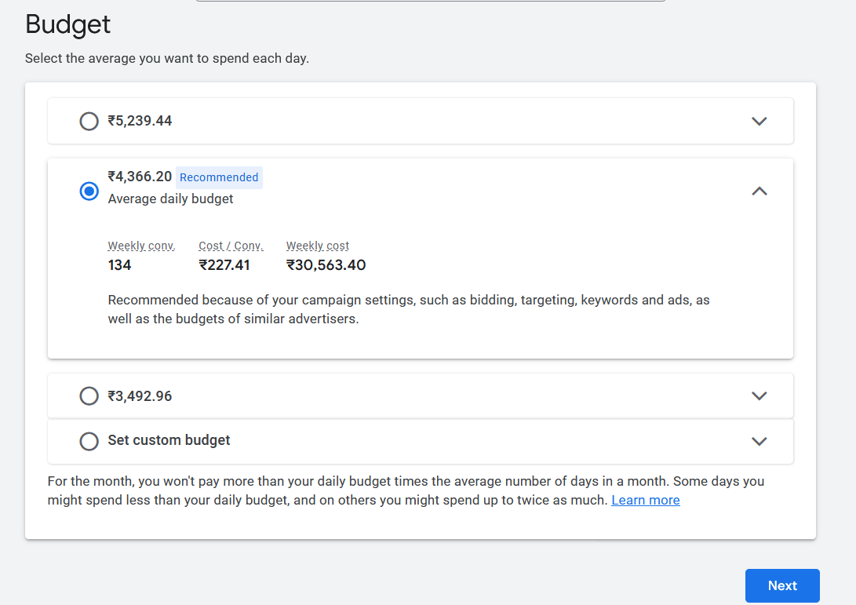

Now above screen will be shown

Now above comes the budget our most important topic is budget

Sometimes it may prompt you to confirm that is this you

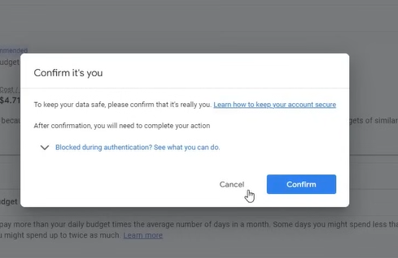

May now it dies not show it

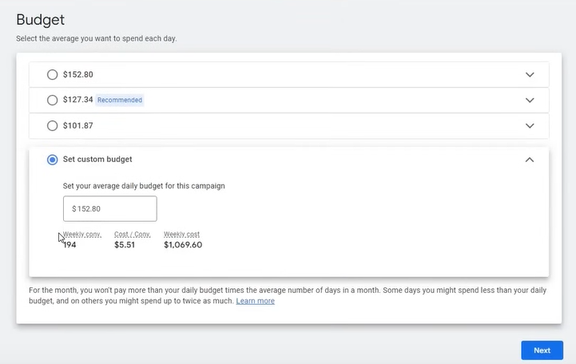

Here in above you have may option for your budget

There are some preset but you can also set custom by clicking the radiobutton Set custom budget

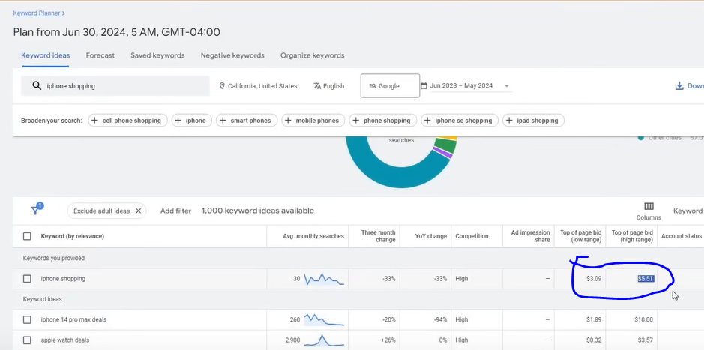

Now Remember when you were selecting keyword for your ads then in corresponding of that keyword

There are two columns one is Top of page bid ( low range ) or Top of Page bid( High Range )

Now a question will come in your mind how we know what bid to set There is a formual for it

So the formual is Add bith the range and then divide them by 2

This measn we will give bid to a keyword according to that formula

It is a way to find mean

Through this formula you find your bid of any keyword

Now how budget will be calculated it can be calculated by multiplying average bid multiply it by the number of cliks you want suppose we target 10 clicks then we multiply it by 10

Then that will be our daily budget

**Phase 12**

Now click on net button now you will see the summar of your campaign

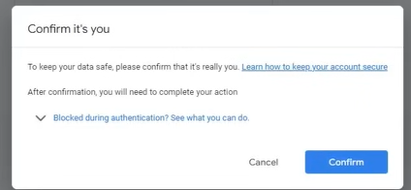

It may ask you to confirm and now click o Confirm button

If there is error then the summary willshow you some errors

It can normally give glitch like keep loading but not giving answer for that reload

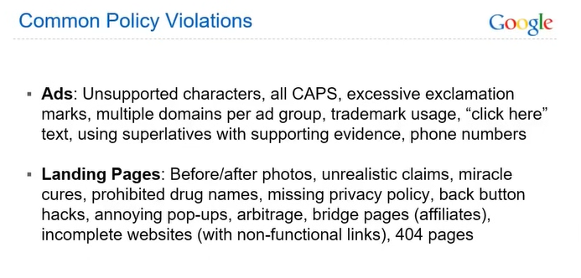

Now comes the Common Policy Violation

Normally the policy violation the people do is that you should no is that in ads you put unsupported characters like / ,- etc These are non supported character your ad will not be approved

If you are writing all Caps then it will not be approved and then comes excessive exclamation marks means you are using too much exclamation mark like 2 or 3 times

Muliple domain in ad group you can only target only one domain in your ad group

Trademark usage means you cannot use name of a registered company in our ad

You cannot write “click here” in your text

You cannot put phone number in your headlines or text There is another way to do it

But not used in Headlines

Next we see what are the policy violation people do in landing page like before / after photo , unrealistic claims like loose 20 kg weight in month ,

miracle cure, prohibited drugs means drugs which are not allowed . missing privacy policy you should have a privacy policy page you should know terms and condition of your website or connecrted I footer

There should be no back button hacks Sometime websites are coded such that you could not go from them by just pressing back button it is not allowed in landing page ,

annoying pop ups you go to any website then a popups will appear don’t do these things

The arbitrage is not allowed here

An example of arbitrage is **when somebody buys a stock on one exchange for ten dollars and immediately sells it on another exchange for eleven dollars**. The person has made a profit of one dollar without having to put any money at risk. This is possible because the two exchanges had different prices for the same stock.

The bridge pages or affiliated links are not allowed

There should be no incomlete website with no functional link

You may have cklicked on may ads when you click on the link it does not work It is also not allowed

Normally when google dtect it after some time then it closes it

There should be no 404 pages

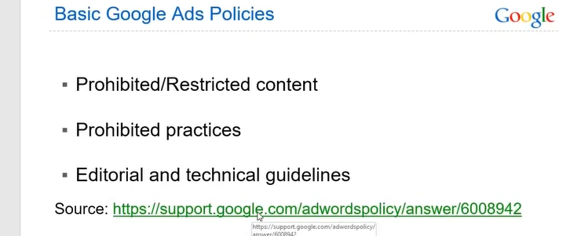

Now comes the Best Google Ads Policies

Now follow the green link given above

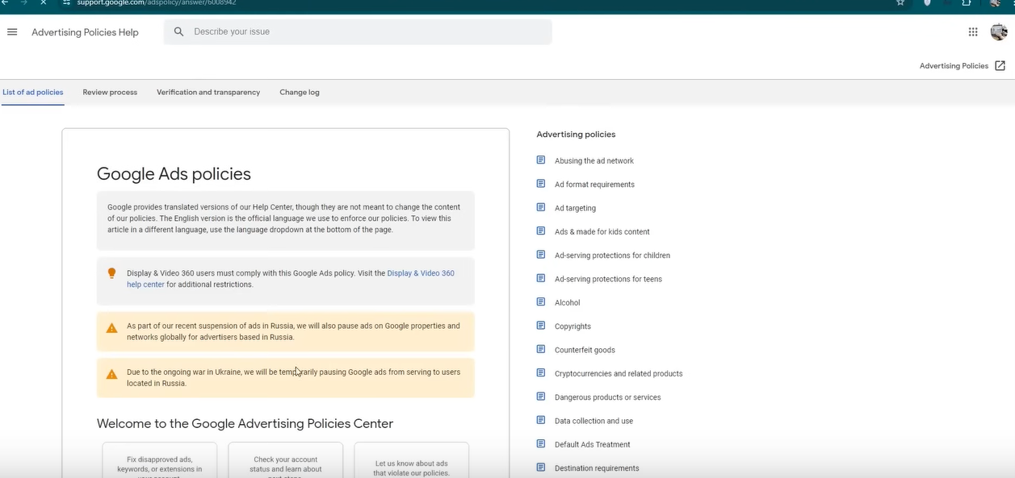

Now above is a Google Ads policies

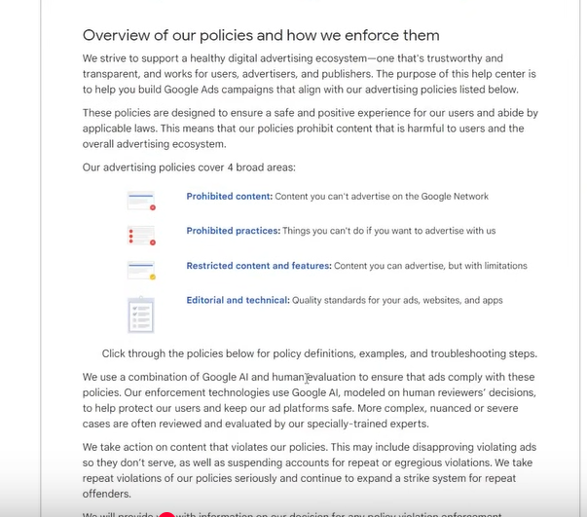

We will understand it so that people will not do the main misatake they usually do

SO there are four policies as shown above

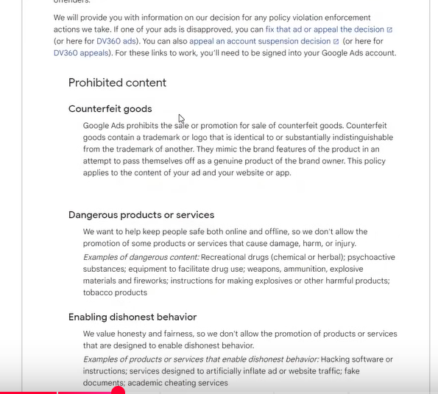

In prohibited content we have

**Counterfield goods** which are those object which are fake abd we sell them

For example if you are selling apple phone copies then it is termed as counterfield

Now comes the **Dangerous products or services** which includes Drugs or Weapons, tobacco . fireworks

Next comes **Enabling dishonest behavior** like you are selling some hacking software or you are selling software to bring traffic to the website , fake documents or cheating services

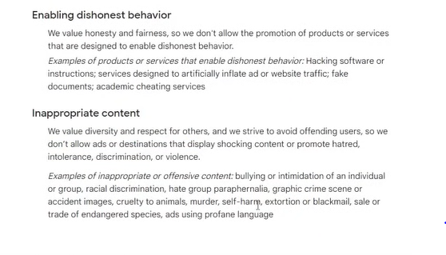

Now comes the **Inappropriate content** in this if you are making content against some group or making racist content , cruelty to animals images, explicit images, images of self harm , blackmail These contains are not supported

You cannot post a picture of crime scene

Noe comes the prohibited practice

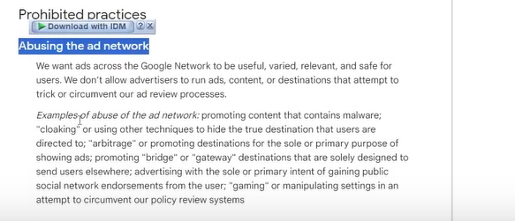

Now comes the Abusing the ad network it includes promoting websites which contains malware and it is stealing the data it is not allowed here

Google will detect it and will ban your account completely

SO don’t do such work wher you are hacking the data of your user

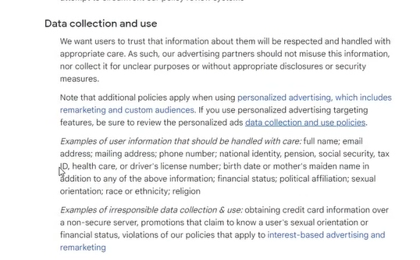

Now comes the data collection and use

In this we need to tell that what we will do to the data by privacy policy and terms of services

And why we are collecting it

And where we will use it and the data you save should be in secure server It should be not like that the data would get leaked and the customer data get hurt Then there should be not something like this

Whatever credit card information you are taking shoulf be in safe server(maybe)

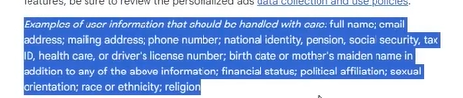

The above highlighted paragraph tells the data that need to be taken care of

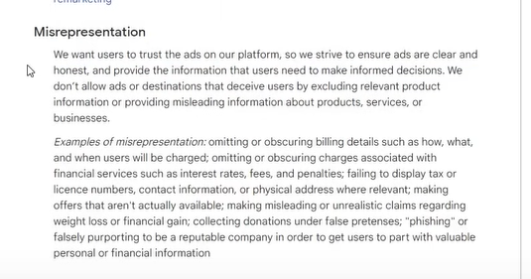

Now comes the **Misrepresentation**

It includes you are not selling what you were showing in your ad or 10 dollar was written on ad and it is showing 20 dollars in the website then it is misrepresentation

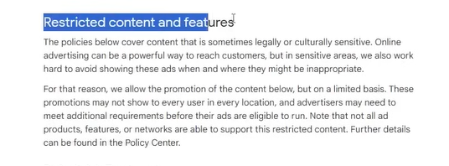

Now comes the **Restricted content and features**

These content are restricted and it is not completely closed basically here 18 plus content or sexual content

These are the things which are allowed

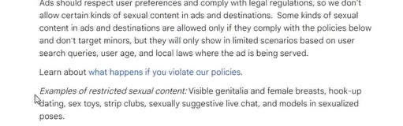

These are allowed in some countries and in some counties they are not

Even in regionwise like in US some states allow It some not

Even if they allow then

Then it says that ad should respect user preference comply with legal regulation means local law of your region

Same for alcohol in some area it is allowed and in some not and it is valid for some age group and some not

IN some area 18 is considered adult and in some 22 is considered adult

So ad should be according to your local laws are they allowing it or not

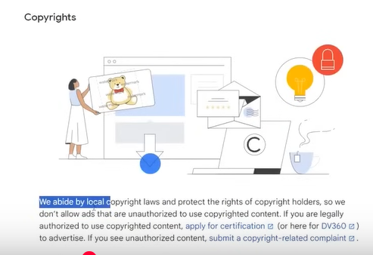

Now comes the **copyright**

It means whatever image you are using in your ad they could be copyrighted so always use unique content If you are legally authorized for that then only you can use it otherwise you cannot use it in your ad

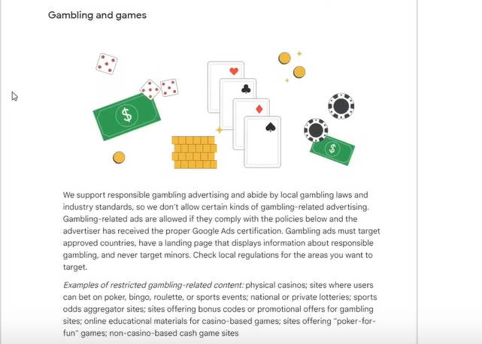

Now comes the **Gambling and Games** like pokers , bingo , or betting apps or website

In some countries it is allowed and in some countries it is not allowed depending on the local laws

**Phase 12**

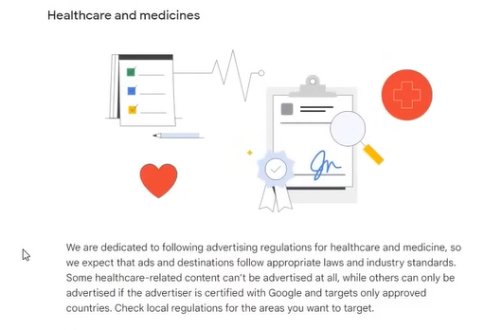

Now comes the **Healthcare and medicine**

Here is selling some medicine you need a certification you cannot do ti some local law should support that and on the basis of that you should run your ad

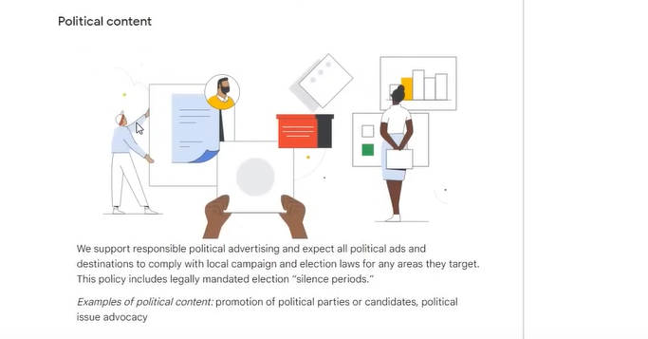

Now comes the political content

As you know political content is not allowed as they support a political party

In some cases they are allowed if they are under in jurisdiction but in Mostly cases they are not allowed

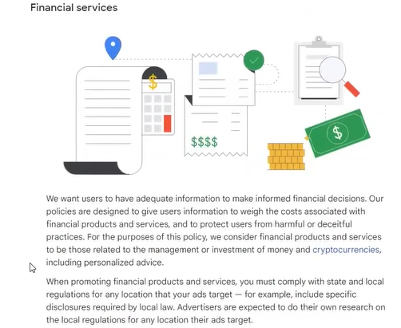

Noe comes the **Financial service**

Like you are managing a financing or selling cryptocurrency or you are giving finance services these thing are allowed in some area and in some not

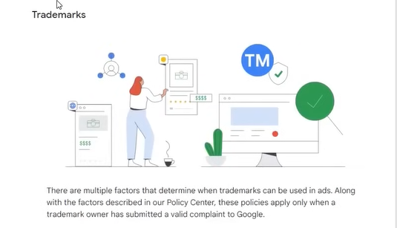

**Trademark**

You cannot use others trademark like google has its own trademark , Nike or other brands have their own trademark

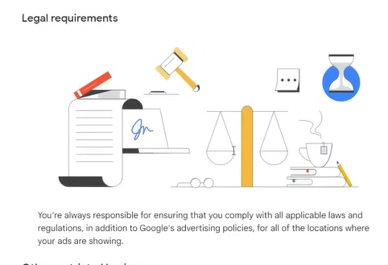

Now comes the **Legal requirements**

It says that you should show ad according to the law of the land

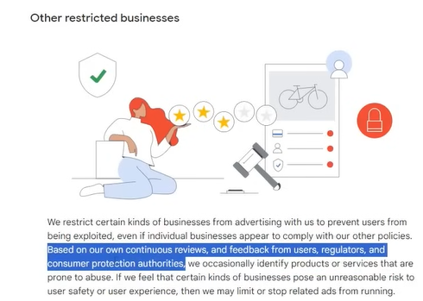

**Other restricted business**

The business which are restricted by ggole based on the reviews and feedback of other users

The google will restrict them if it thinks that these business are not safe and there could be user harm then on that case Google does not allow it

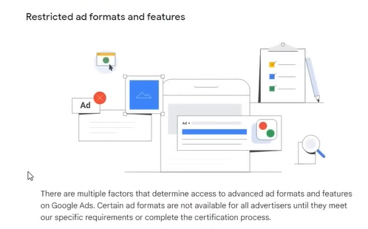

Now comes the **Restricted ad formats and features**

You can rwad the paragraph shown above

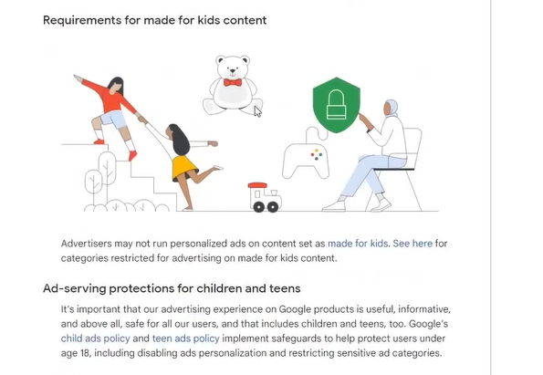

Now comes the **Requirements for made for kids content**

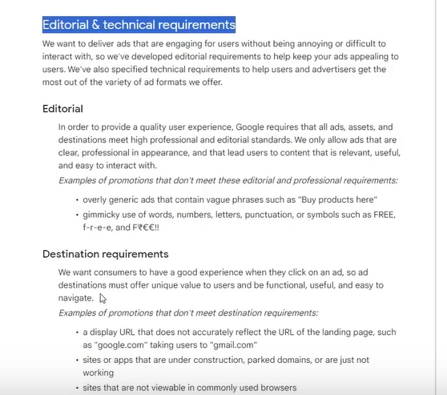

Now comes the **Editorial and Technical requirements**

Editorial mistakes are not allowed as shown below

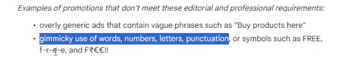

Now It says in first point that ads should not be generic that means it should not have a phrase like Buy Products here

And in second point it is written that you cannot use gimmick use of words ,numbers, letters , punctuation For example you cannot use the wod Free as shown above

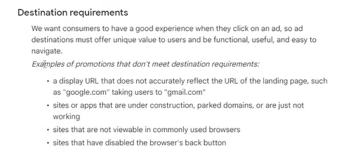

Now comes the **destination requirement**

So from above four points

We know that display url should reflect the actual url

The link should not be working and it should be opened in all browser

Your back button should not be disabled of the website

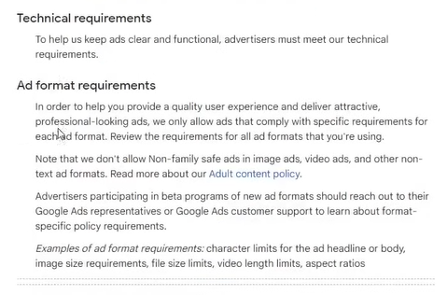

Now comes the **technical requirement**

In this we have asd format requirement which maybe we will see later

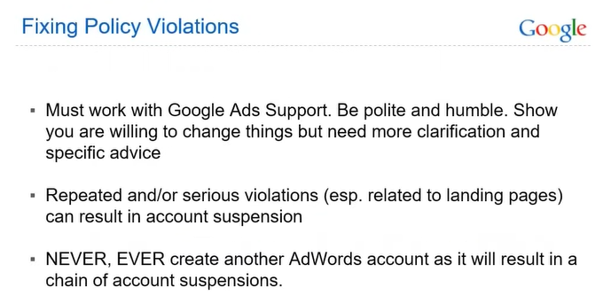

Now comes the **Fixing Policy and Violations**

If you by mistake violate some policies then you need to contact to Google Ads Support

Be polite and Humble to them Don’t be angry to them and don’t fight with them

Even if they don’t understand that then you need to explain them everything calmly

Make sure that hey understand everything also tell them the backstory

Always follow the policies It should not be like that you are not complying to the policies and you say to them to correct their ad account it will not happen because the policy will remain as it is you have to comply to them

If you are violating same policies again and again especially related ot landing pages and you know it then your google account may get suspended

If your account get suspended then you should not create another account Many people do this and their new account after the suspension will also get suspended. Instead talk with google supported sollve the issue If there is no fault of yours then it gets resolved

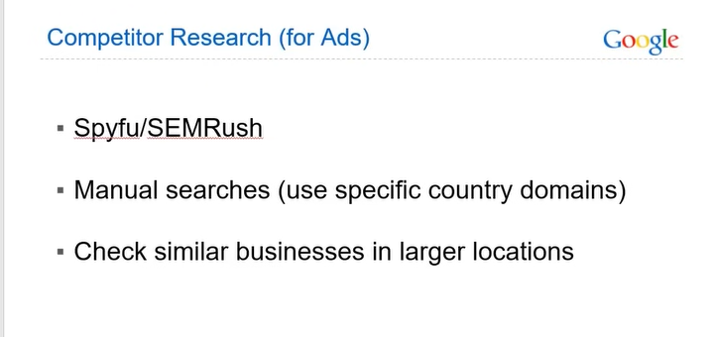

To learn from youcompetitote above is the tool through whioch you can see your competitor ad

Like facebook has tool for seeing rivals ad and research ad Like google has similar feature

Search about something and go to a an ad link and click on the three vertical dots associated with it as marked below

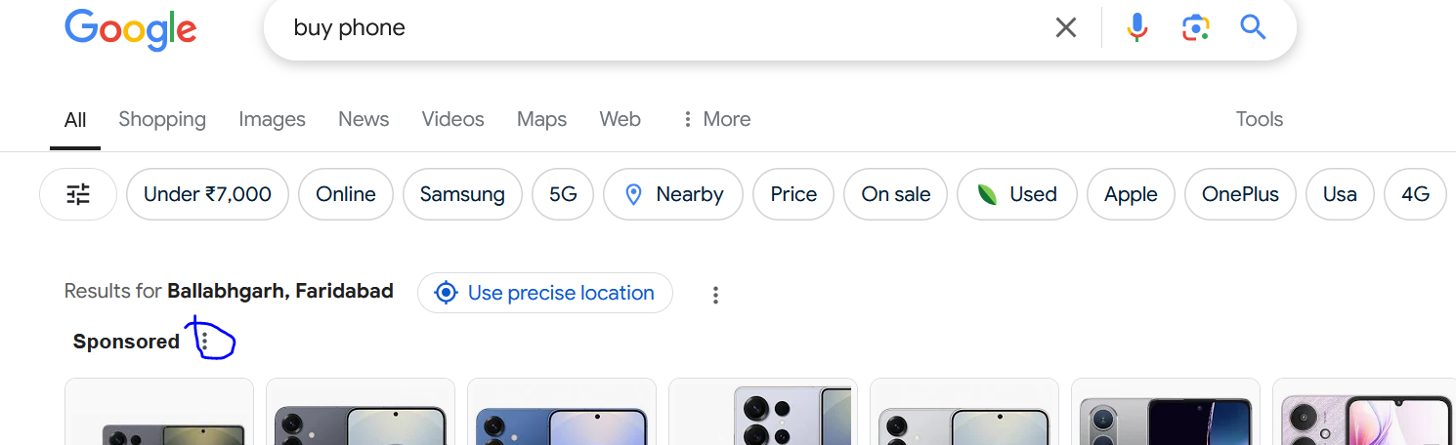

Now a window will be opened as shown below

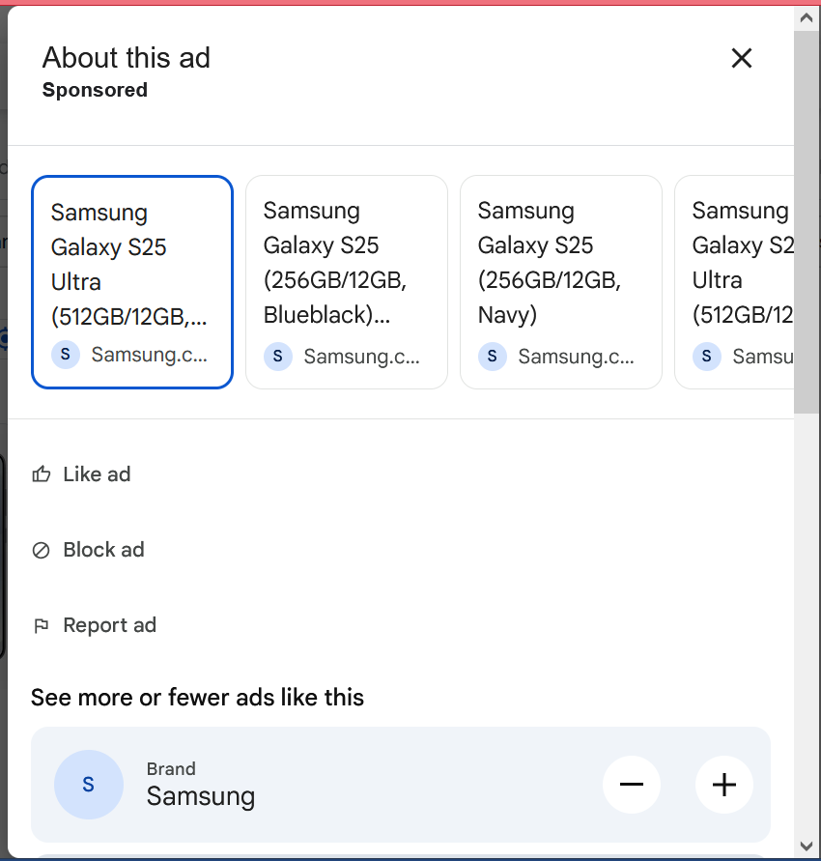

Now drag down and click on see more ads as shown below

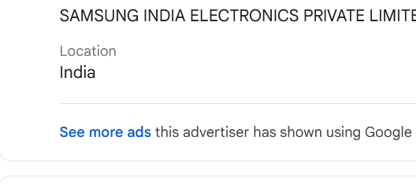

Noe a new page will be opened

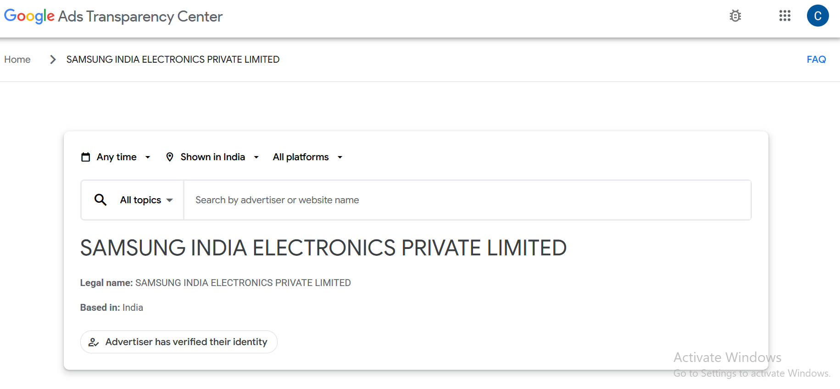

The above is the google transparency center as shown above

Here you will see all the details of the ads in a particular region

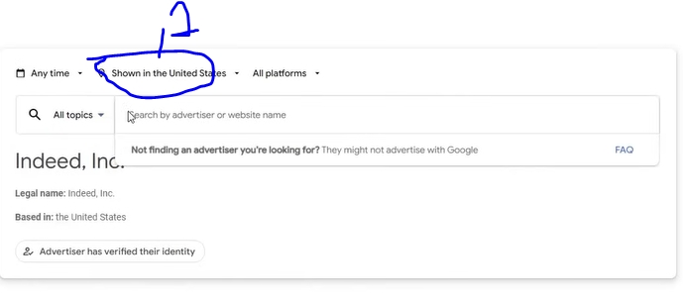

In marked 1 you can choose the region and in the text field you type the website or the key word of the ads to search ads

Now if we search nike then below option will be shown

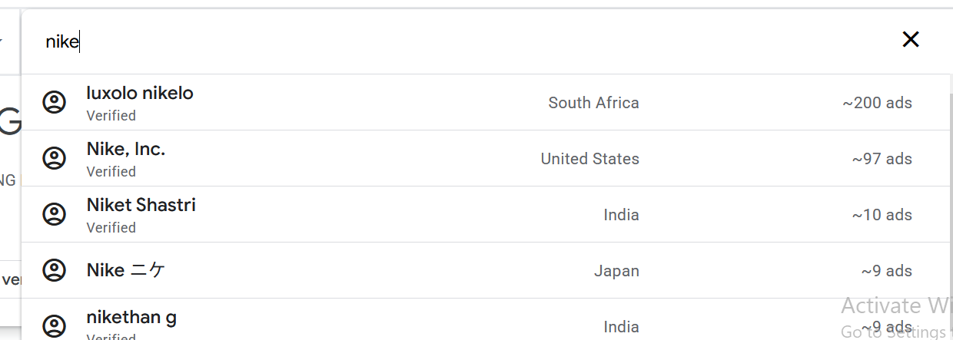

If you click on nike then its all ad will be shown in that specific region

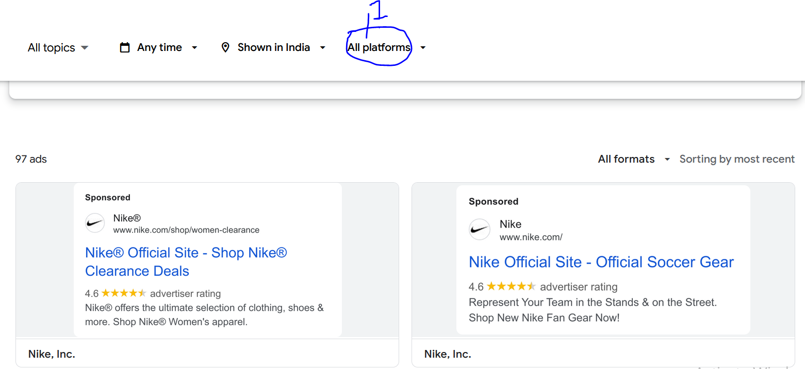

Now the ads as shown above

You can see their ads format , what is their headline, description etc

How it is doing you can see it all

IN marked one you can filter according to the platform it is being shown on

You can also set the duration in the filter by clicking on any time as shown below

<https://adstransparency.google.com/advertiser/AR16735076323512287233?region=IN>

So now above is the url where you can spy on your rival

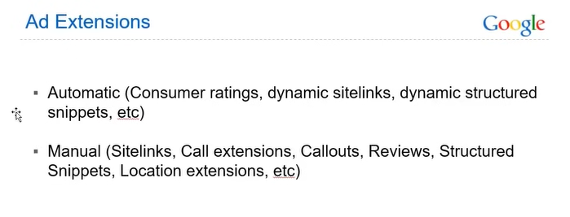

Now Next comes the Ad extension as shown above

**Lesson 7:-**

In this lesson we will learn about **Google Ads Extenstion**

IN ad extension there are two types of extension

First is Manual ad extension and automatic ad extension

By automatic we mean controlled by Google It automatically run it we can disable it in Google Settings We cannot edit it We can only see which ad is running and have run in the past

How many clicks were on it and which were running in the past(I think teacher is talking about ad made by Google )

SI the recommended option I manual one

To disable the automatic ad extension open any campaign in Google ads

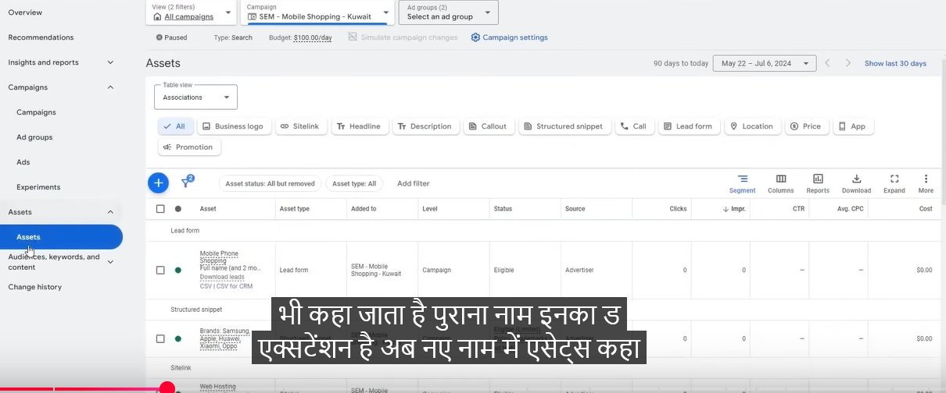

Now after opening a campaign above UI will be shown(Campaign should be published)

Now go to assets it is other name of Ads extension

Ads extension is its old name

**Phase 13**

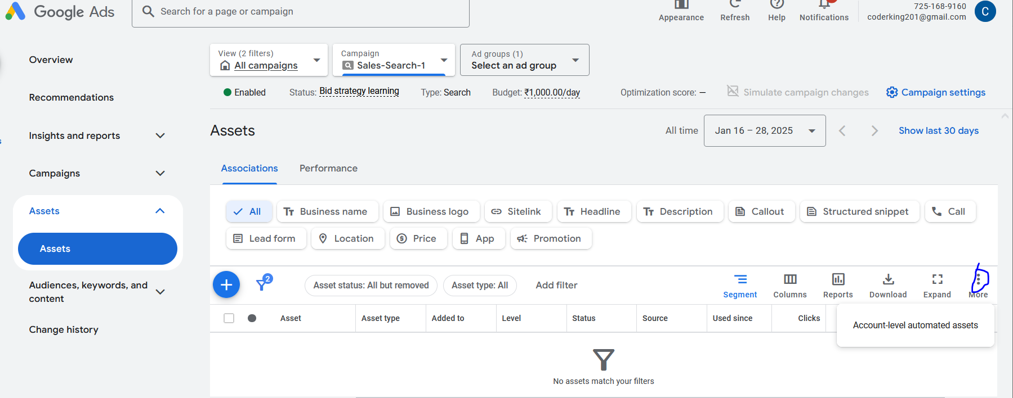

Now click on more as marked above and then a submenu will open click onAccount level automated assets

And now it will look like below

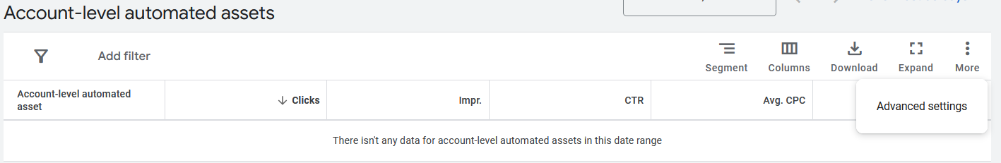

Now click on More button and then in submenu click on Advances Settings

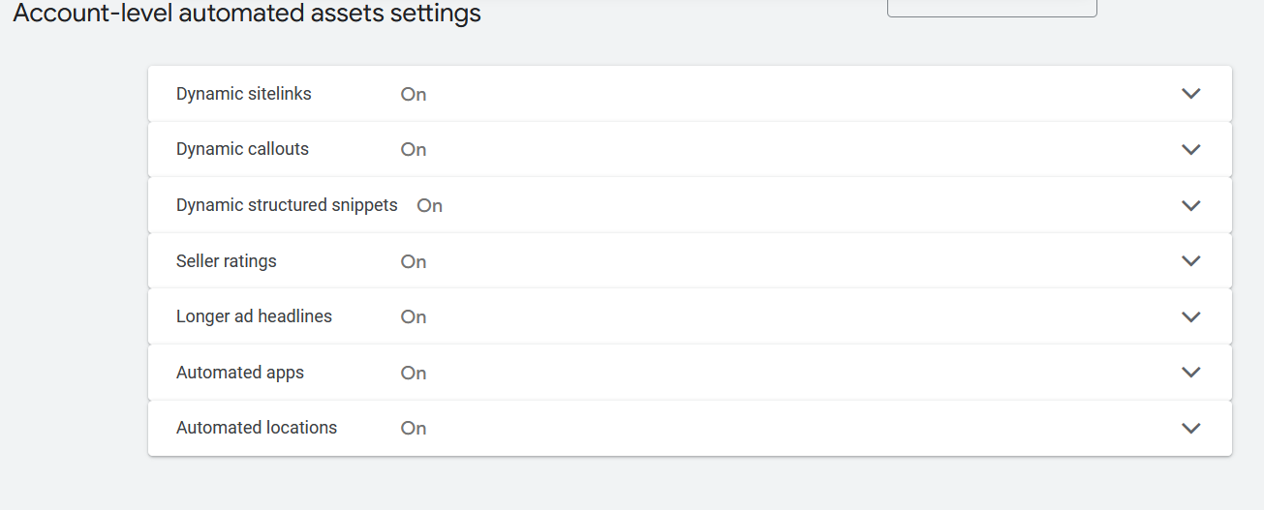

Now you will the interface above   
Now you can see this is a very hidden option becaue google does not want you that you reach it and disable it because it want you keep spending automatic nad your money keep going biut we are not doing this we can manually make good extension for it because we know what things are going well and what not so we disable them

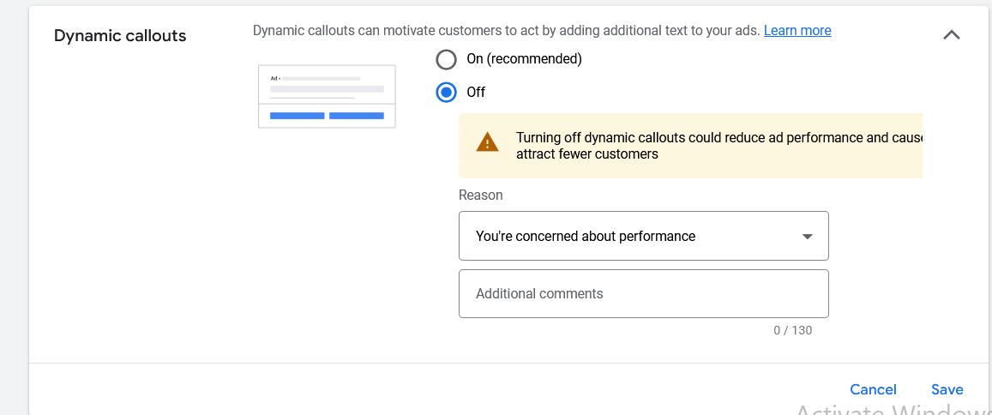NOw off them by expanding them and then choose the off radiop button and then in reason we choose You are concernec about performance

And then click on save button

It is recommendd to disable them

Make your extenstion will be better for you

Work on manual extension it is not a tough task it can be made easily

Now comes the manual extension

Now yoy will see the types of manual extension we have

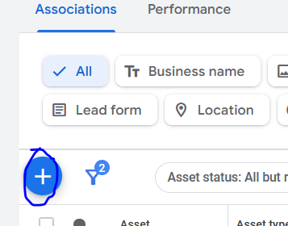

Click on + button as marked above

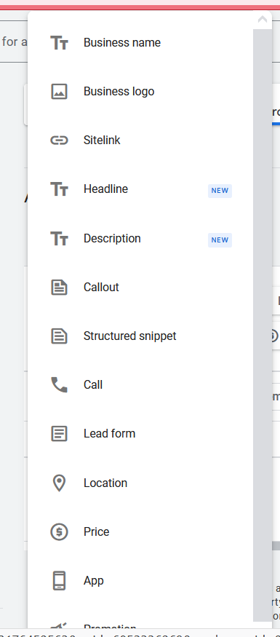

Now a submenu will be shown all of the options are the assets or ads extension

IN the anove options the automatic and manuals are mixed

5 or 7 of them are automatic extension

The business name , Business Logo, Sitelinks , etc

We will see each one by one in detail

How these are extension are formed and what are there use

First comes Business name we click on it in the submenu

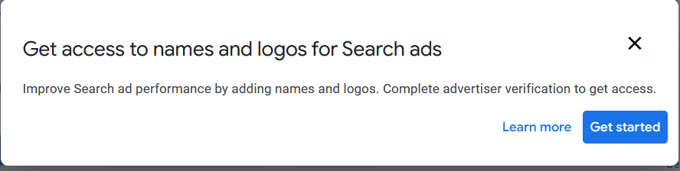

Now a prompt will appear now click on Get Started button

Now it is saying above to access this property you need to so advertiser verification

Means you cannot just add your name or logo

You need ot submit your document. You need to tell about your company . and then you will be allowed that you upload your logo r add nick name because this is Google Policy that you do advertiser verification then these things access will be given to you

To study what it is used for

So Suppose we search mobile shopping Kuwait

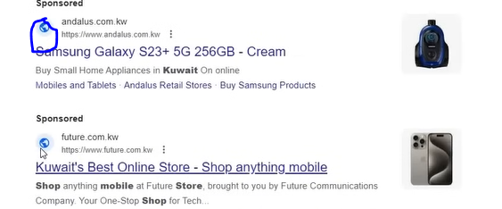

And now in above marked above you will see there is no logo here

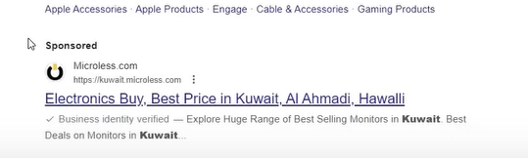

But in another ad there is logo

It means they have done advertiser verification and they have added their logo here

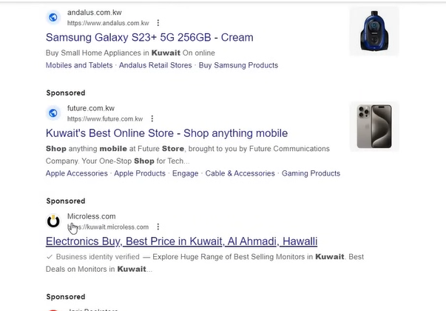  
Now you will observe that in every normal ad the heading(maybe) match with the everything text coming after // in the url

But not in Microless

There is Microless.com written above but there was supposed to written Kuwait.Microless.kw

This is because of Business Name or maybe business Logo

You will see becaut this ad had logo it will look prominent

Business Logo and Business Name extenstion or assets ar recommended

If can do advrtisation verification then your performance will be better

Noe we study about sitelink

NOe click on sitelink in the submenu

In this extension below your ad extra link come up for example

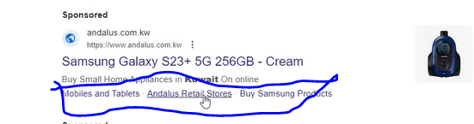

Now in above marked you can see links related to the ads website

These links are coming from site link extension

Now we are searching Mobile shoppings then by that keyword we cound not understand that what product we going to buy

Then through this the person can be shown option here in sitelink

Like Iphone , Samsung , etc

With the help of this your customer will directly land on your page associated with that thing for which it was clicked

Customer will get good expoeriece

The chances that the customer will convert will be increased

IN some cases there was dexritotion used ot come with it in desktop (maybe on mobile also (who knows))

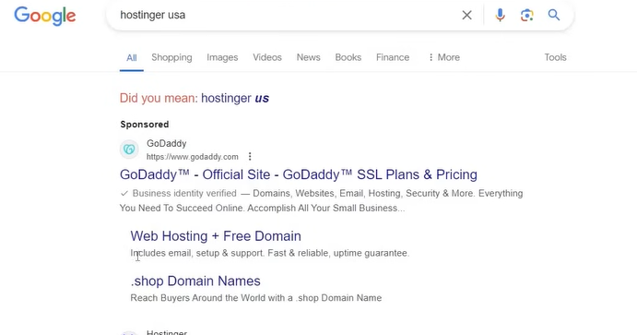

Now you can see the ad as shown above indented link you see above is actually is sidelink

But there is descrioion here due to which it is shownlike that

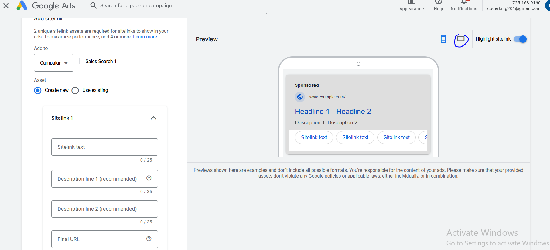

The above is the sitelink page

After filling the sitelink text and descriotion you need to enter the url

Here Don’t give the url which you have given in ad you are already taking raffic there in the main link

But now you want to add extra pages there so that the person can click on the sitelink and reach that page associated with the topic of the link

The link may be long because you are running ad on your page and It may have pixels die to which your url may have utm parameters

By clickin on above marked you can view the ad in desktop view

Recommended Minimum number of site link is 2 and the maximum number of site link is 4

And in site link there can be n number of links

The google keeps chaging it so it is not confirmed yet

You can use it when need and when a situation require it

SO if you are providing different services then it is ok but if you are providing one service and the user also searching for it then there is no reason to use it

People take people to iother unnecessary pages will not give them any benefit

You cannot give good convergence there your effort should be to give good experience to your user The whings he want to find he will get it

If he don’t get the thing he want then he will not trust you

People use it when they don’t even need it

Which is a bad thing due to which you can get negative traffic and your revenue is not generated from it which is a main mistake

The google give the option of 20 site link

Upto 20 is not required otherwise it will rotate it too much and testing on it that you don’t want that to happen and spend too much on it

**Phase 14**

Now in extension we choose **headlines extension**

It is newly introduced It is used to add extra 2 or 3 headlines ad

Same we can say foe **descriptnion extension**

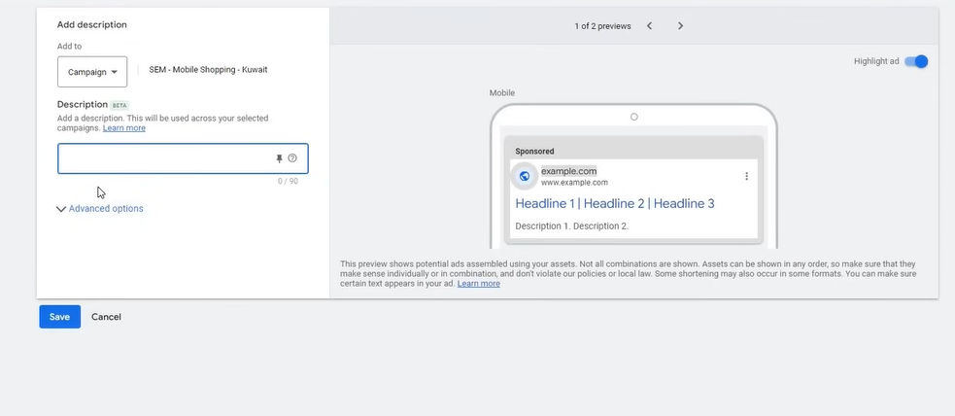

NOw comes the **Callout Extension**

What happems in this extension is that it is not a clickable link but a text after the description there ar some additional text comes

Now suppose we have many category of phones like Samsung, IPhone, Redmi or Mac etc

Then ad will look lke below

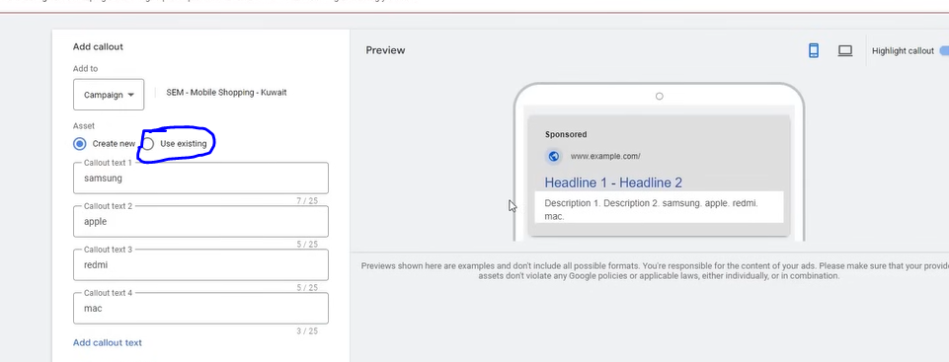

By this your ad looks big and prominent feels good

You don’r need to wrote something which you had already wrote

Try to write things which will attract the person and the information you could not give you give here

As you remember focus more on benefits less on feature

SO focus should be benefits

Try to tell about benefits more

If you have created a call out then you don’t have to create again

You can reuse it by clicking on the Use existing radio button as marked above

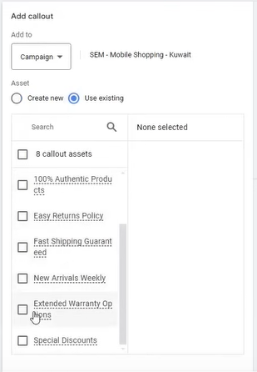

And then you can choose here as shown above

You can use these callouts in another campaign

You can limit the scope of the call out by clickin on

Addto field as shown below

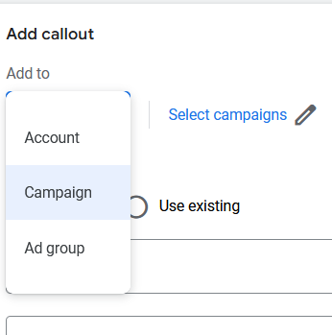

Click on account to choose the scope of this account and in campaign choose the campaign you want this callout to limit to

Now click on save button

Use callout for any business you want

Use upto 5 callout It will be good

it could be telling like free shipping , 24 /7 customer support , high quality service top rated or best rated in the town you can also use chatgpt to assist you

NOw comes **structured snippets extension**

Like callout it is also text based

In this extension you type text by choosing category

The category have many items or values

So if we choose Brand and then in a value we type the brand then

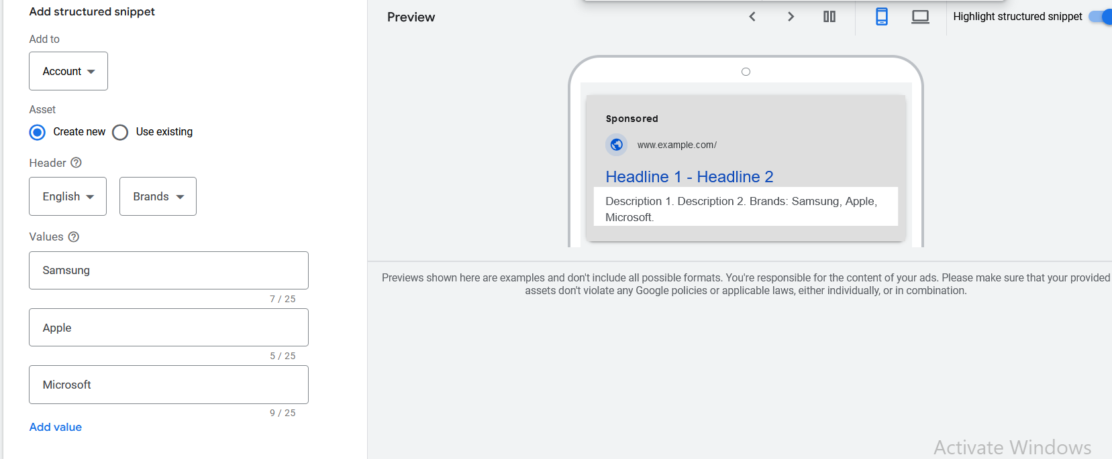

It will look like above

You can use these prebuilt category

Now we have Call extension

It is one of the most crucial extension for businesses which generate call or wan more calls for their business It is good extension for them

Before setting it up we need to set up tracking first

Now cll is coming how will we know it

WE can also track how long the call was we can also know it in Google ads

For that we need to go to Goals side menu

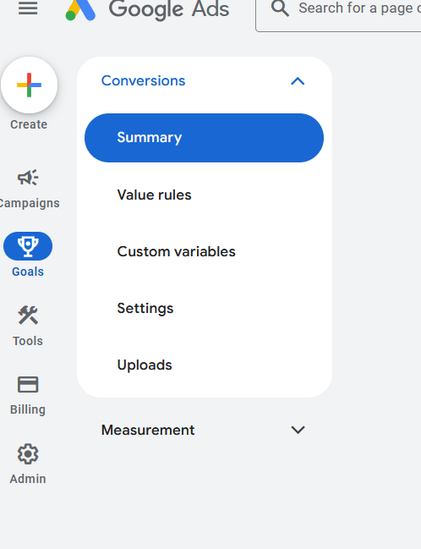

So before setting up call extension we need to set up its tracking

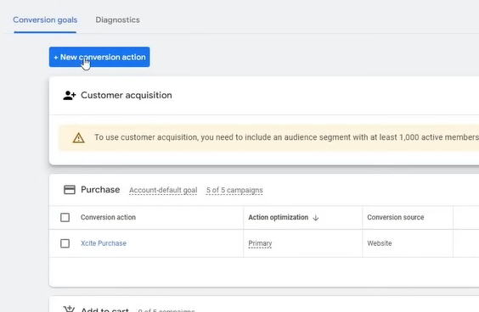

Click on Create new conversion action

Below the button we will understand everything later but for now our focus is on how to set up tracking for the call extension

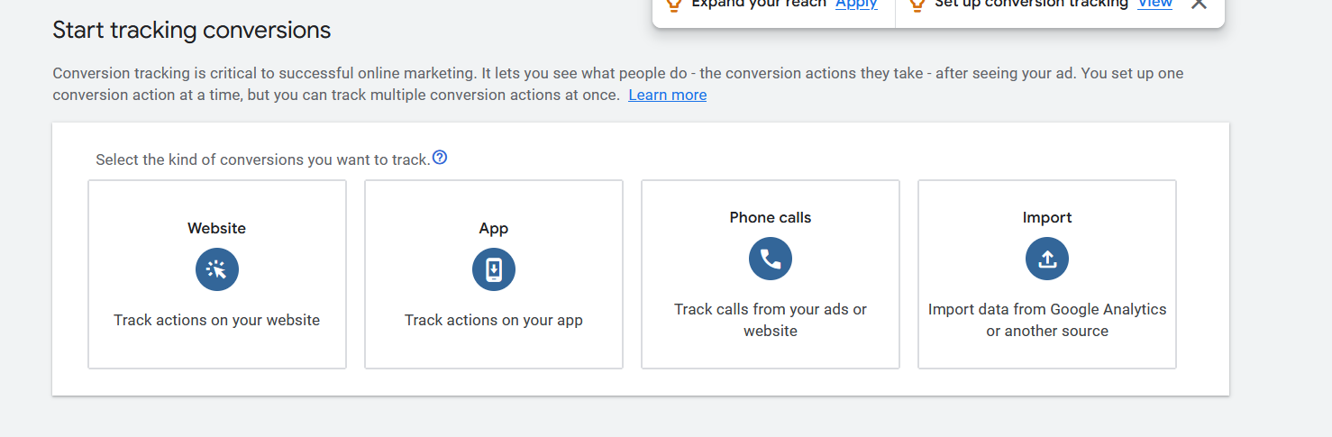

Now above page will be shown

We clcikj on Phone calls because we want to track them first

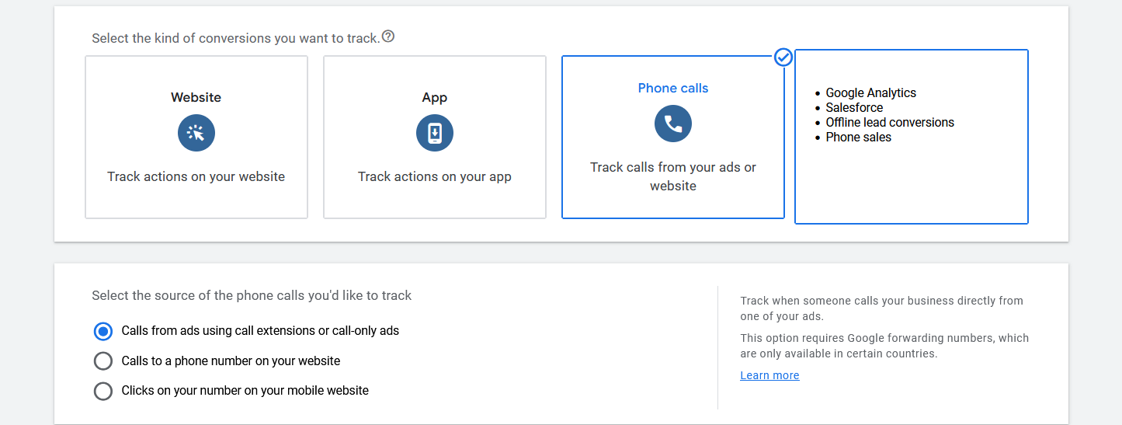

After choosing Phone calls three radio button will be shown choose the first option

Calls from ads using call extension or call only ads

Now click on continue

Now this page will be shown

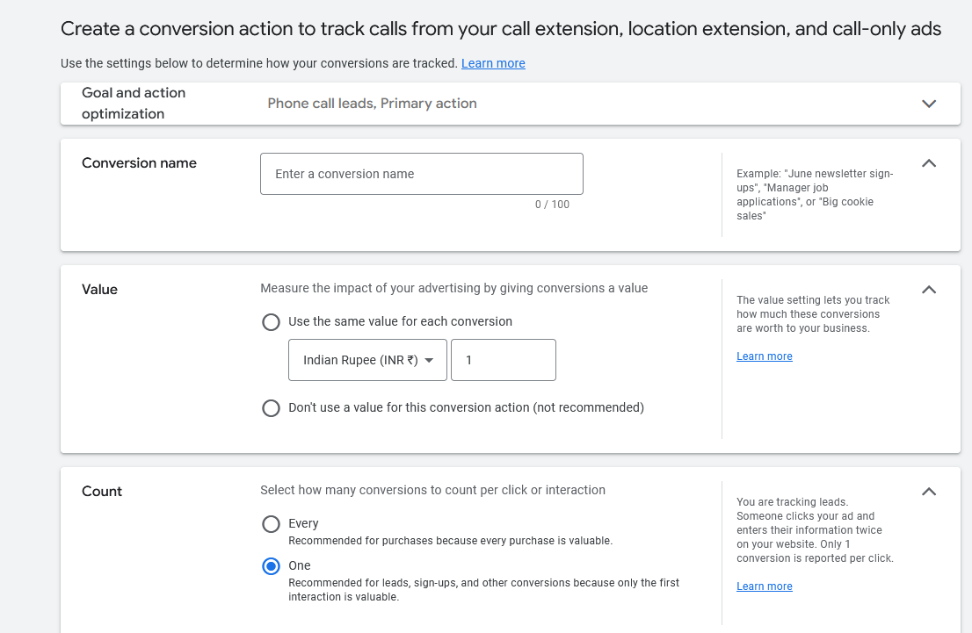

Its details will be told later but for now understand that we are tracking our calls how long they were

NOw do all the configuration shown below

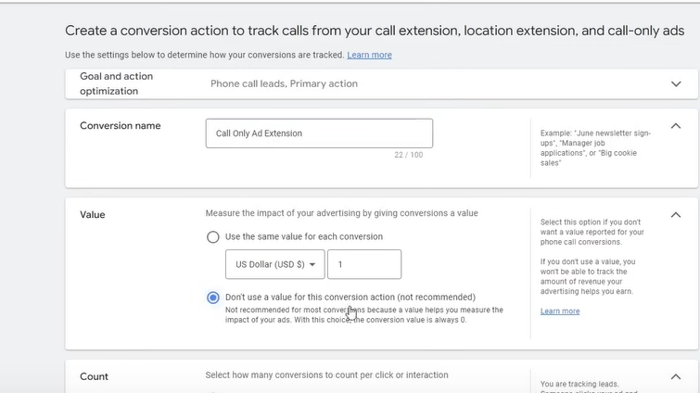

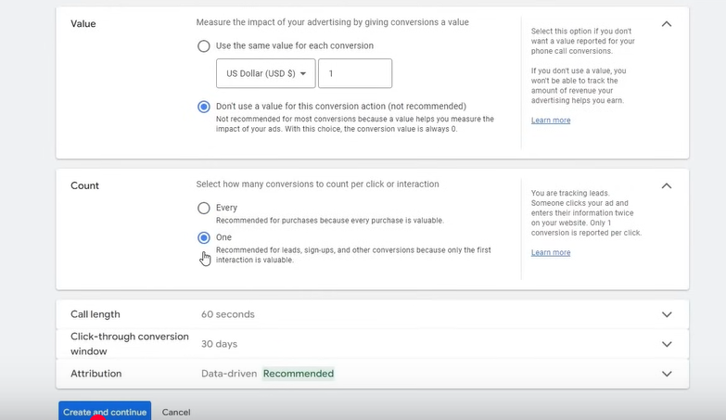

Now choose one in the count section

Because if a person is repeatedly calling you then you would not want to track it everytime because same person is calling repeatedly

In Value section we tell the revenue we decide

What revenue generated you want for that call

So we choose second option in Value section

In call length type 30 seconds

If the call is goes beyond 30 second then it will be treated as a conversion

Now click on create and continue button

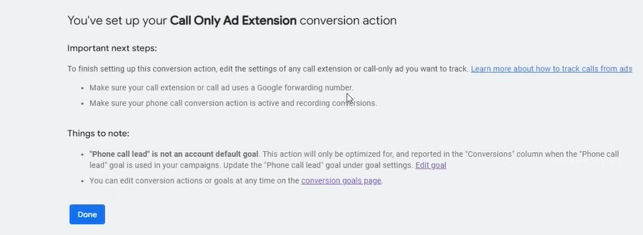

Now our convergence tracking is formed

Now we can create an extension

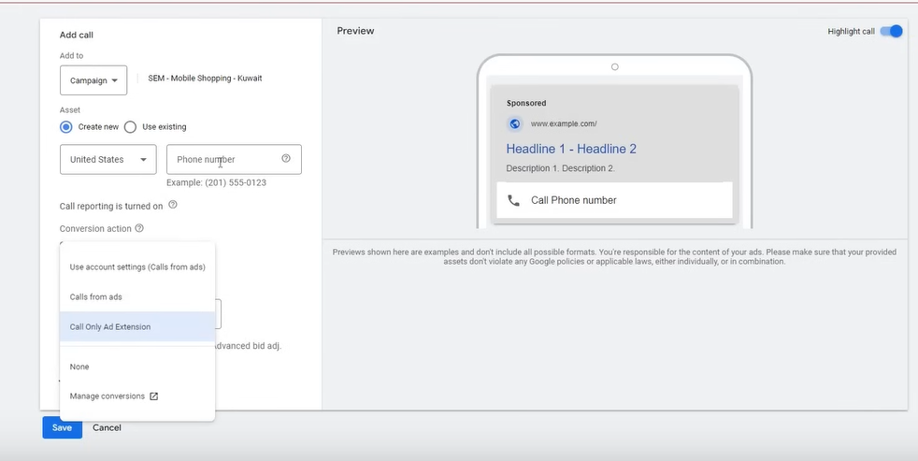

Now in your call extension In your Conversion action choose the call action you made

You can add any country phone number or go to use existing radio button and choose the phone number which you had used in the past

I don’t know what teacher is saying

We will increase or decrease the bis by percentage according to the interaction as shown below

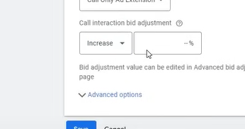

Call extension should be for the

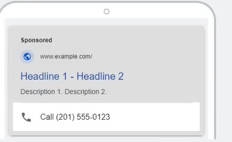

Business who are doing lead generation or handling calls , for local business

Now comes the **lead form extension** (see in detail later(It may be used to create form to fill the details and generate lead))

Now comes the **Location extension**

After clickin on git a new page will be opened

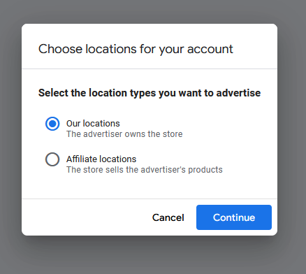

And there will be a prompt shown to us

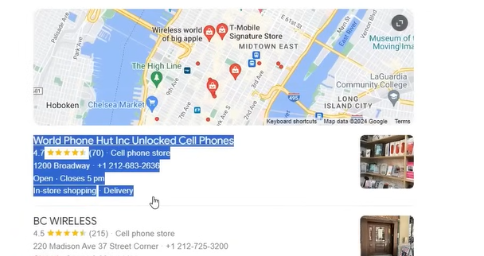

Now here you se above selected these are the listing mentioned google business maps(who knows)

We call it GMP listing they are also called local listing or organic listing

**Phase 15**

Technically they are called GMP listing or Google Map listing

You have added it in your google

If you want to run ads on them or promote it

Then click on continue in prompt after clicking on Our location

Now this prompt will open as shown below

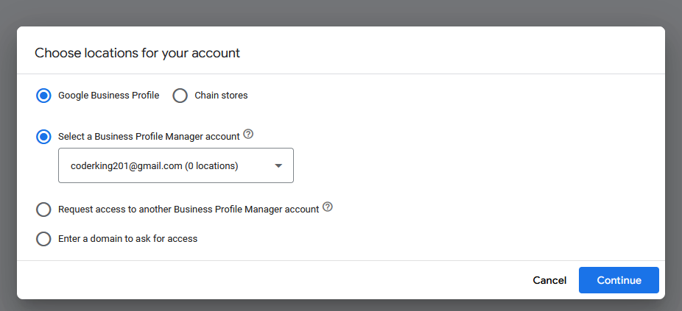

NOw you can see above the email is linked to 0 location

In third option you select when you want to acces of another business profile manager (who knows)

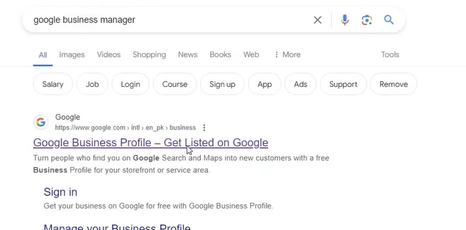

Now if you search google business manager then go first link

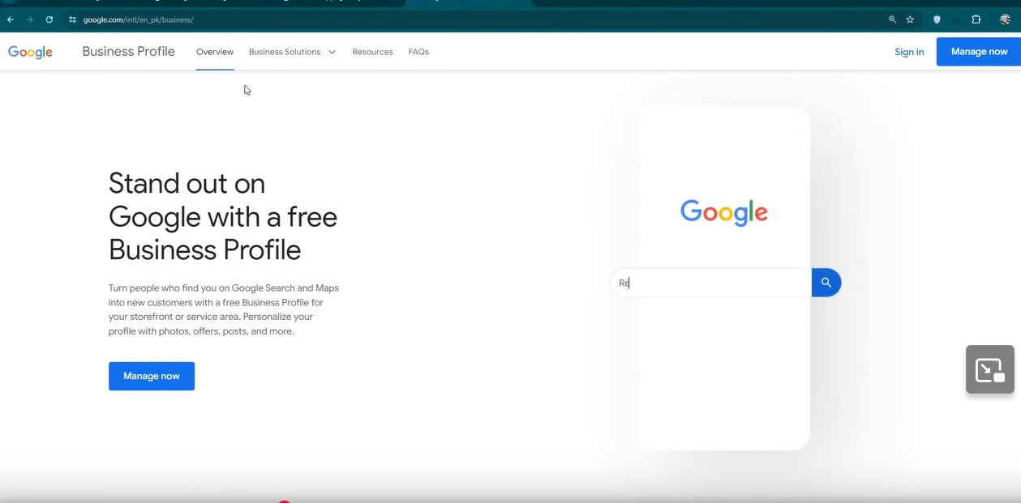

Then above page will be opened

Here basically you can list your self in it

Here you create an account and there you list you r business

And give access to it to the ad account by cliciking the this option as shown in the prompt

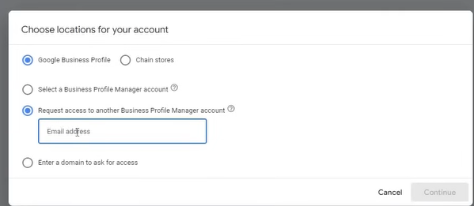

NOw the email through which you made the account you need to dent the request there

The person will accept the request to whom that id belong tonow if you check the fourth radio button

If you cannot find the email then target the domain

The promt will be updated

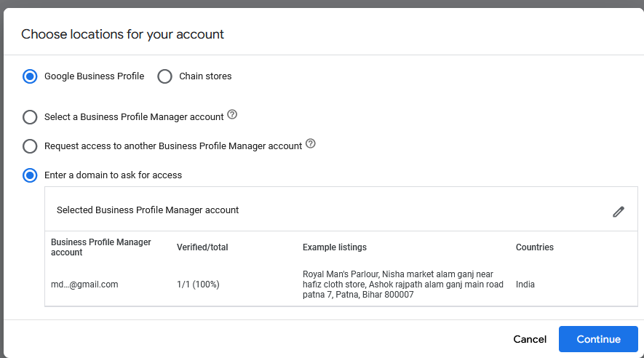

Select the domin you found and then click on contoinue button and now clck on continue

Now you will be directed to google ads dashboard(maybe)

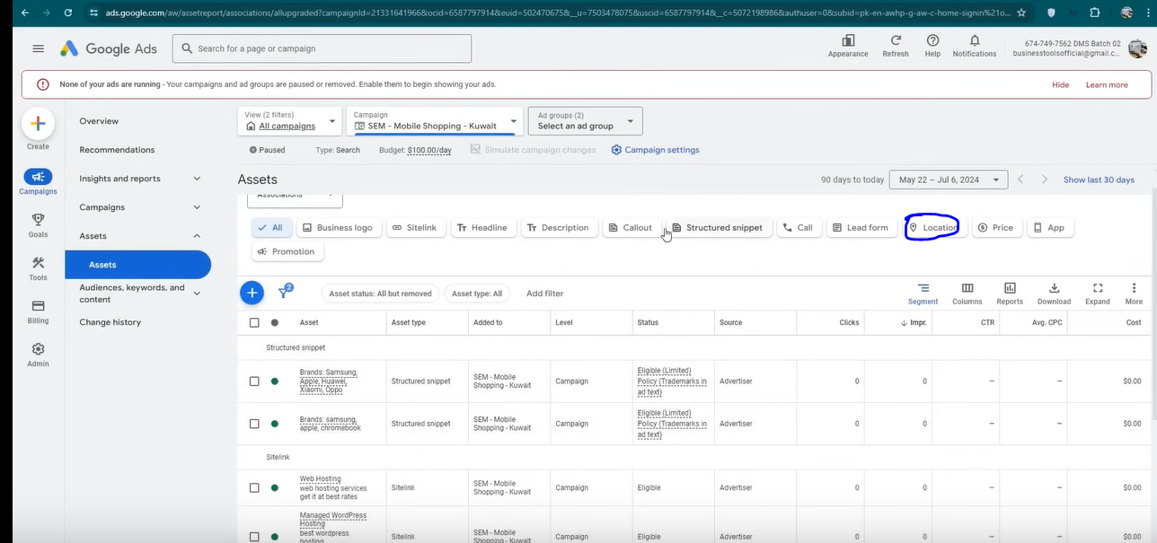

Filter it according to the location y clicking on the filter as marked above

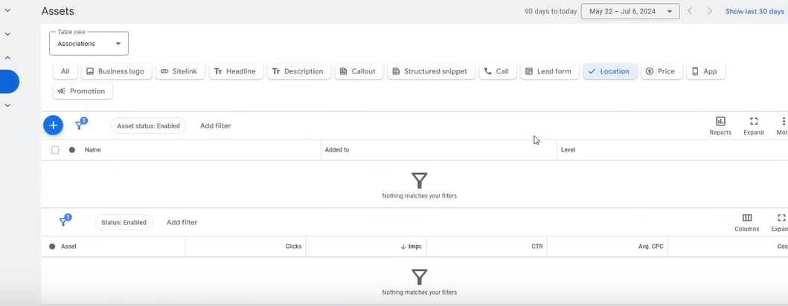

Request has gonw there and when it will be accepted then it will come already

After selecting the third radio button and then clicking on chain stores then below will be shown

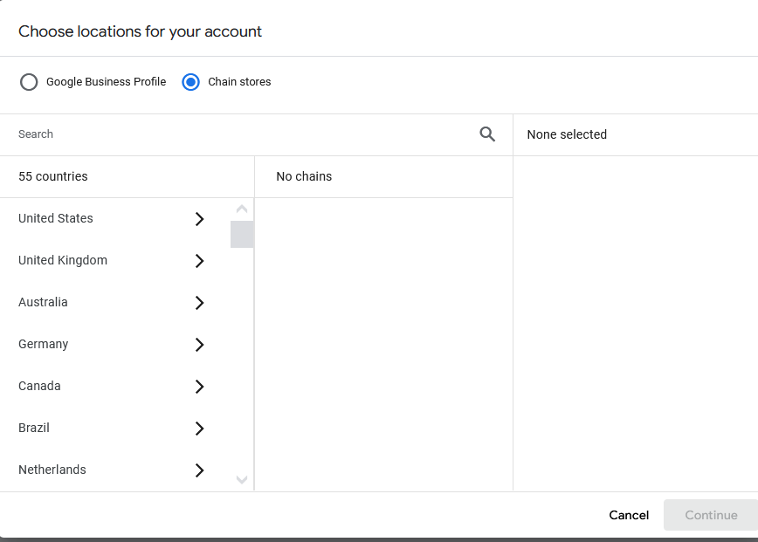

It is for the option you have multiple stores in different location and you want to advertise all of them by selecting them

It is not recommended because it get difficult or technical

It should be paired with this or that (who knows)

Teacher recommendation whatever there is store keep them separate you need to advertise your different stores in different campaigns so that you don’t mixed up there locations (who knows)

Who should don’t is

It should be done by the one whose business demand footfalls who want that the customer should physically appear like local business or business in which customer have to physically appear to take the service like dentist etc

We will try to use it where the user can gain profit from it

Now comes the lead form

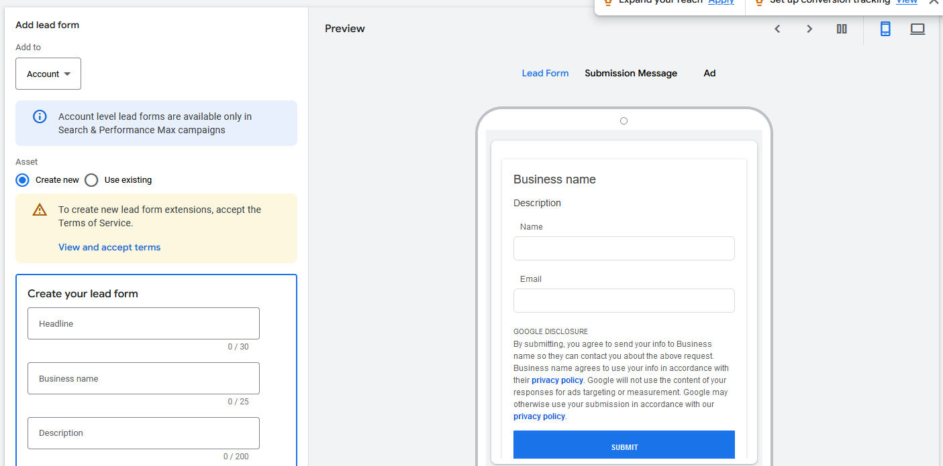

You will see the from as shown above

Here either you can create new or use existing by clicking on their respective radio button

Like there is Facebook form leads there is Google Form leads

You see the lead option in your google ads

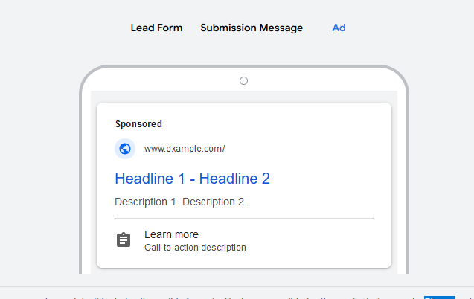

You can precie you lead form different aspect

TO see how will it be then you can click on ad to see it in ad form

The Learn more you see belwo the ad by click on the user will reach the form and when he will fill the form tehn you will get the lead

What will be that form we need to tell it

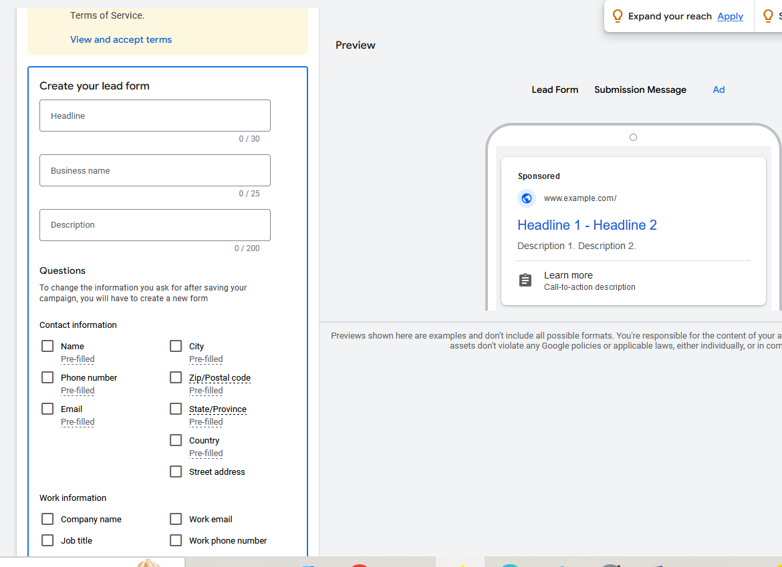

In Headline you will tell the headline of your form

In description you set description

In Business Name you set Business Name

IN check box you decide what type of question you need these ar predefines question

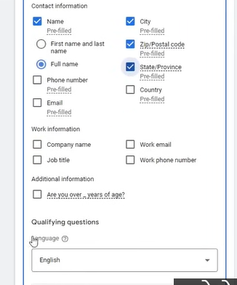

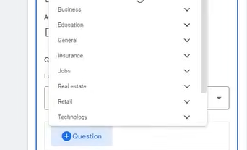

Click on the question option above now a submenu of question will be opened

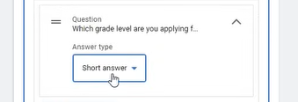

Now you can set the answer for it in short answer or MCQ

You can also add prefill question here

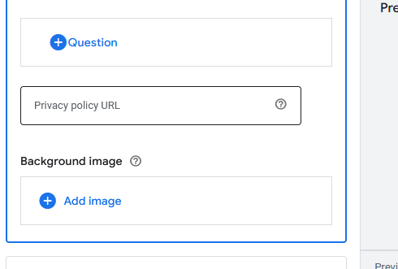

Then it may ask you privacy policy url

It is important without it you cannot submit the lead form x

You can also set the backgrounf image of your form due to which you form will look good

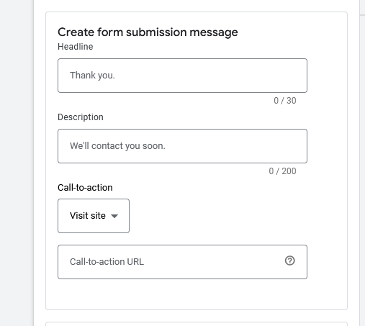

And now you can customize the form submission

Click on submission message option in preview to see the

You can also tell call to action in submission message

Smetimes in Googel ads a bug happen such that when you enter something or add something then In oreview it smetimes does not reflect the cahnges

In call to action url you tell the url you want to be loaded if you click on the call to action button

Whatever shown on the ad you can customize it as ahown below

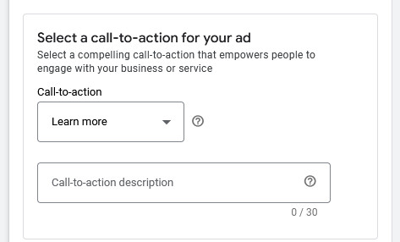

You can also add it to accunt or campaign

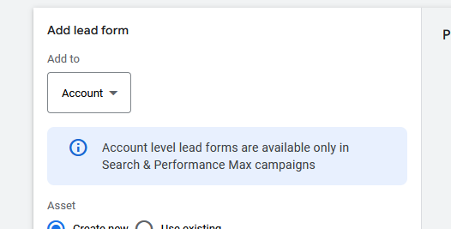

To use this fomr later in different campaign

Only one form is allowed in your ad

You need to delete it to use it (who knows)

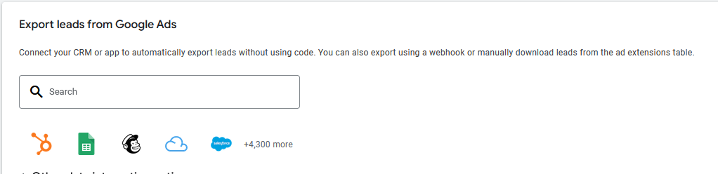

In above you can integrate and export the data to Google sheets or you can set up the coinversion for lead form submission

You can set up the conversion here of lead form submission (who knows)

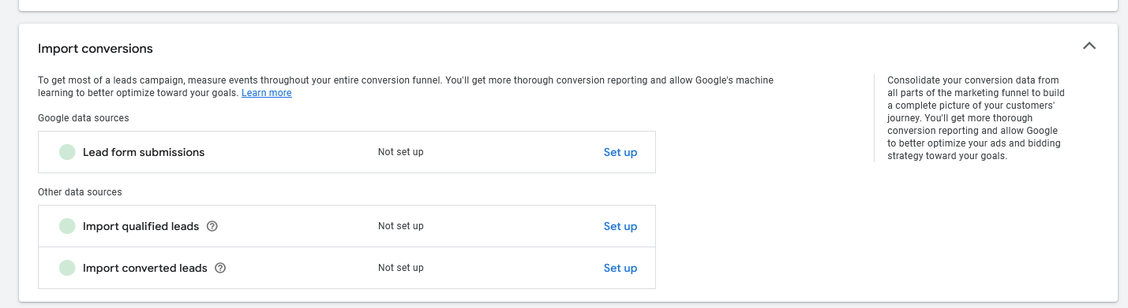

We should do lead form submission or not Its answer is no

Because it does not have good result

We have tested it multiple times and it result doesnot cme good usually

Lead comes but there quality is very low

Means if you call 10 people then not one will converge

If you call 100 then atleat 1 will converge

Leacing it there are other things on which when you do spent then there could be benefit

There will be noi benefit

It ca happen that Google ads team will recommend yo to run Google ads

!st ry=ule of google ad is that don’t listen to the Google team beacause they will recommend you such thing by which your ad spent will be increased and eventually they gain benefit

Even the Big shots or mentor of Google recommend this

**Phase 16**

The people who contact you or customer representative

They are not even trained These are those who have some level of basic knowledge related to it

And thery don’t knoe about anytihing related to it

Now comes the price extension

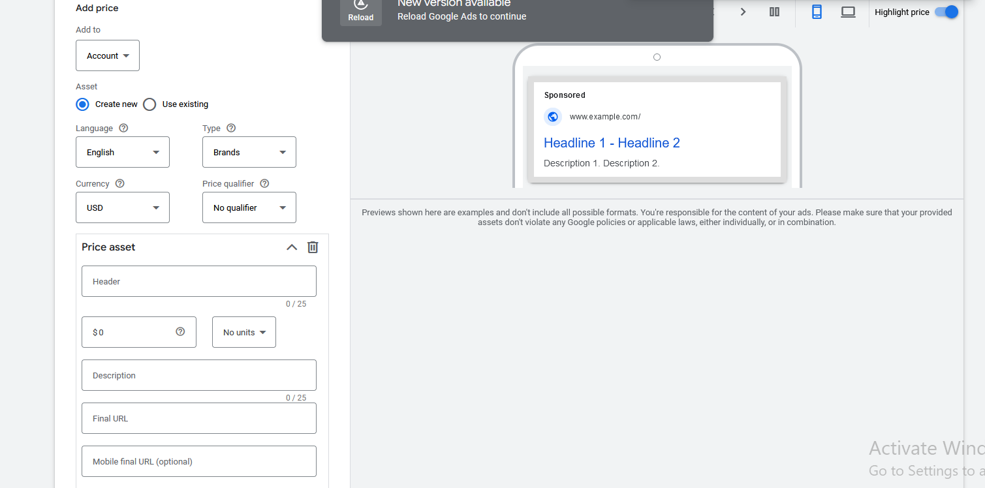

IN the langiage you choose the language in which you want to show the price in and in the type you tell what things you are selling

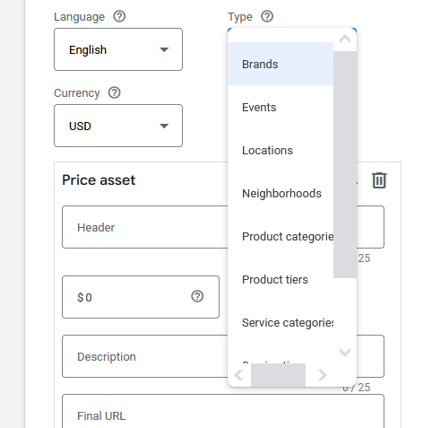

So click on type as shoen above

IN currecncy field you tell the currency to the price

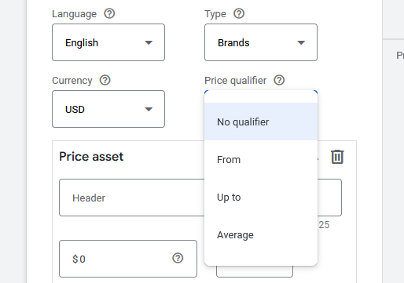

NOw Price qualifier telll you how you want to show the price

It basically tells you range or the exact number

If from is selected then it will tell the minimum price from which the price start

If up to is selected then maximum range is told

If No qaulaifier is selected then it is telling the exact price

Now in price asset as shown below it tell us the price asset maybe telling more about the price

What is the charcteristic of price(maybe)

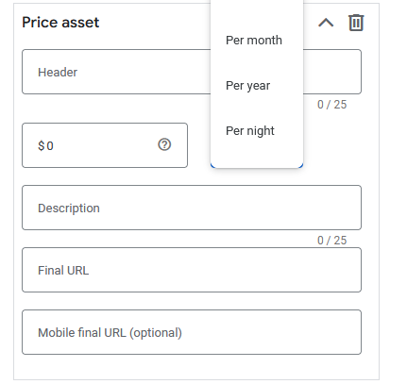

IN header you tell the header of the price(you can add the brand of the product to whom price belong to)

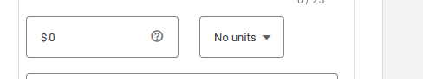

Now if you click on no Units then it will give you option about how you wat to pay for the [roduct

Like if you are charginf for a room in hotel then you can choose per day or per night.

In Final url you tell the url of your product

Mobile final url is not needed anymore as noe the websites are responsive but previously it was difficult to do there was different links for dektop version and different for mobile version

Here you can create multiple price assets according to your need

Now click on Save button

Whether we should use it or not it all depends upon your experience

And now comes the app extension

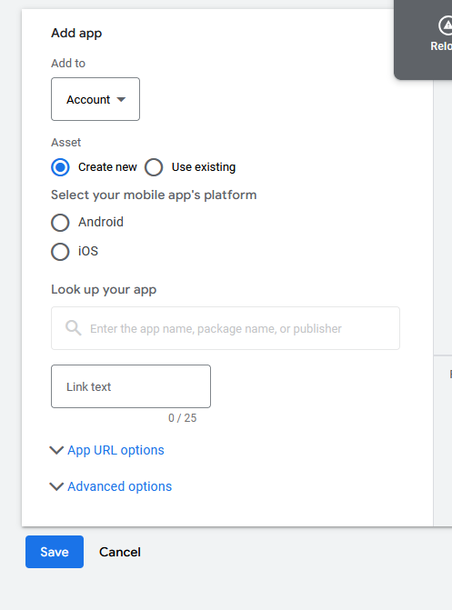

Now In our app extensio there are two extension that is Android extension or IOS extension

You can choose either of them

In the look up your app search about your app and then select it

NOw in the review you can see the ad with the app logo logo

And in link test you tell the text you want on your call to action button(maybe)

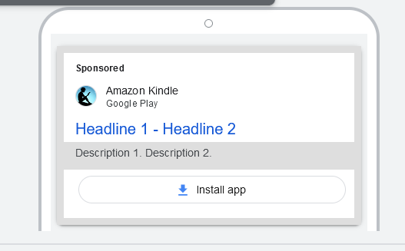

You know that all does not have app it is very rarely used

SO if you have app then use if not then don’t use it

Now we come in our last extension that is promotion extension

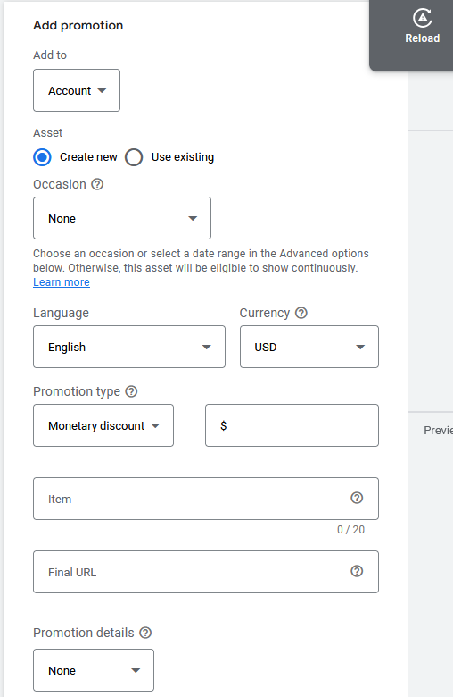

In app promotion we can tell what discount we are giving and How much

In occasion you can tell on what occasion your selling your product . In occasion it can give option like Black Friday ,New Year etc Choose noe if you don’t want to give occasion

In promotion type we tell what type of discount we are giving

If we choose monitary discount then it measn the ammount you want to deduct from your amount

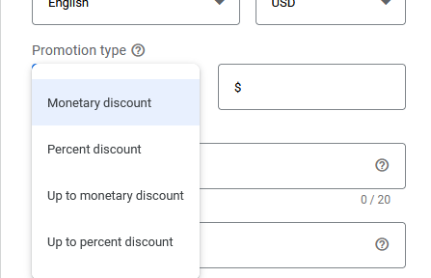

Suppose you choose 50 rupees then 50 rupees will be deducted from your total amount

If you choose percent discount then certain percentage will be deducted from your amaount

If you choose Up to Monetory discount then it gives maximum amount you can defduct it can be less than it

If you choose Up to Percentage discount then it gives maximum amount you can deduct it can be less than it

Initem field you tell the name of your item

In item you can also tell to use a coupon

And now in Final url you tell the url of the product

It is recommmeded by the teacher to use it in all ype of businesses

So we saw type of extension we have and what extension to use and what not to use

So we have studied it one by one

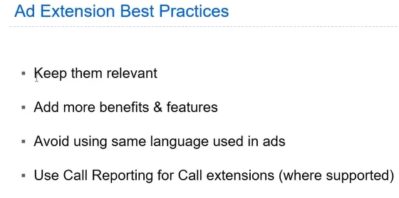

Now comes the Ad extension Best Practices

First point is that keep your extension relevant and you sould try that form user side user is gaining the advantage or not If he is not getting the benefit then leave it and if he gain profit from it then go for it

Second point is what the tacher has said earlier that is Add more benefits and features of the product

Third point is that avoid using sam languageused in ads If you have added some USP in your ad and you are keep repeating it like 50% off erpesting in every add then it does not run you hve to use different language for it means you have to cinvince them by using differnet ways you need ot use different extension to tell your USP or benefits to customers in different ways

Now comes the Use Calls Reporting for Calls extension (where supported)

Which teacher has already told you

**Lesson 8**

In this lesson we will learn about **Landing Pages**

First we need ot undersrtand what are landing pages

Landing page is where your visitor will land

If you are selling a mobile then for a mobile you will not make it land the customer to the website because a website has a variety of products so you make them land on a specific category of the mobile and you will its url or link

Its simple definition is that in which page you want to land your visitor whether it’s the home page or service page or any product page

Suppose if you are selling a body then to sell it then it does not mean you make them reach the home page od the website you can make them land on a specific category or a product page

So landing page

**Phase 17:-**

It is included in our syllabus because in google ads your main cinversion , sale or leads comes through landing page

So it is very important that you design landing oage in a very proper way

We follow best practices of landing page so that hey does not go away from our landing page and they can be converted because the flow we seen in landing page is that sometimes the button is not working and the page is not opening up and checkout is not happening and many information is being asked in checkout There are many unnecessary information buttons are not working and you are not getting other option that how a person can contact us Such problem should not be faced by the customer for that we need work on landing page that’s why teacher ask developers to design there web page on the basis of some guidelines which are being given by the teacher to us tht what are those guidelines , what are the tips or strategies that are implemented when landing pages are designed then you can tell your developer or you can your self made it



Now you can see the landing page of client of our teacher

The first important thing(big one) you see above is the headline Our Headline should represent or explain our service measn whatever we are selling they should properly coimmunicate it

You can see below the Headline you can see the USP of the products or fetaures of the service or product

You can see teacher has tries to directly communicate with the customer by tlling the benefits of the services

Some people just fill it means they overtell about the service and the customer get confused that what you are selling here there should be good commuinication with your customer

Whatver we are selling the customer should also understand it If he can understand it then he can buy it so important thing is that the content you are seeing in landing should not be in detail normally people just fill paragraphs which is not needed by them

You can use bullets point here you should use more designing , make attractive images or short section that is enough

In SEO you need long form content but in PPC you need short form content that’s enough

SO always try to use bullet points more and use short paragraphs and don’t use long term platform

What teacher structure usually is giving Headlines and then bullet points

And he tries to write something that can increase the chances of convergence of a cutomer

And then call to action

You can add one or two CTA It all depends on you x

Generally what a teacher does is that if for an international customer for example if there is a client from US

There is no use of using Whatsapp CTA because internationally whatsapp is not used in US

Then there we replace CTA of whatsapp with the form CTA

Now you can see in header there are manus and then there is call to action so that we can easily convert our customer

Now remember these menus navigate in their own oage rather than different page

SO we are basicallyb trapping the customer here so that he will not go outside this page

Whatever contant is inside the page is very relavant in nature

Whatver thing he needs the teacher has put it in this page he does not need to go out of the page so whatever he need will go there

The strategy of Teacher for landing page the teaceher use is that he uses single page lnading page because by them it is easy to converge them

Many people also use multi page but the teacher prefer landing page

And now in that page we have made an about section

Content is not also in detail

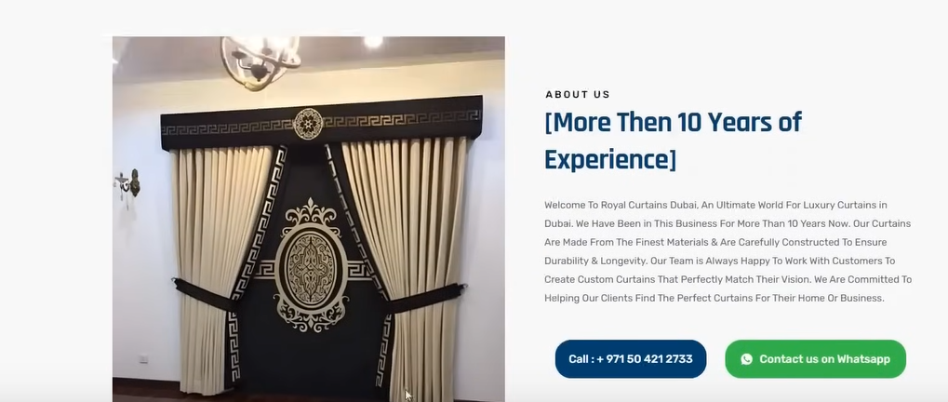

Ad then inside it we have again Call to action You may have notices that we have used call to action in many places in that page so that if the customer is at the bi=ottom of the page he does not have to go up

Here we have form and whatsapp floating point

So anywhere the user go he has option to click on call to action

He don’t have to use buttons

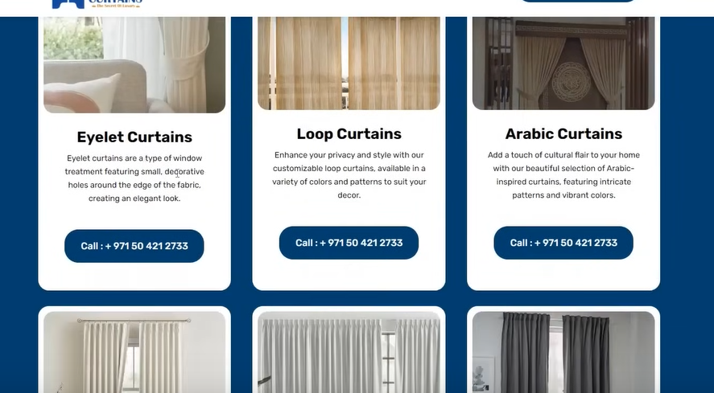

NOw we have shown our services as shown above

You can see above that the description an services are so less normally it is very large

You can see the call to action possible it is very important that there should be call to action It is very important that it should be mentioned in many places

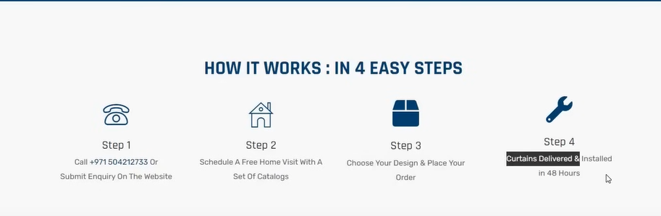

And now he tell us above how to book the services

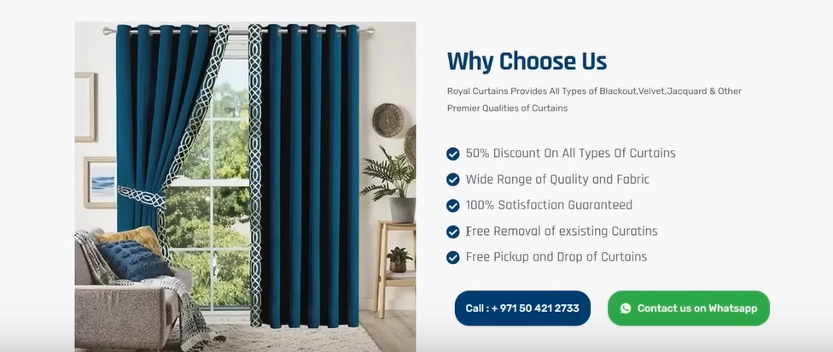

Now you can see why choose us section

Here he has used bullet points here

Here teacher have focused on features

Here there is also call to action

Because teacher want that wherever the user is he should click on the call ot action

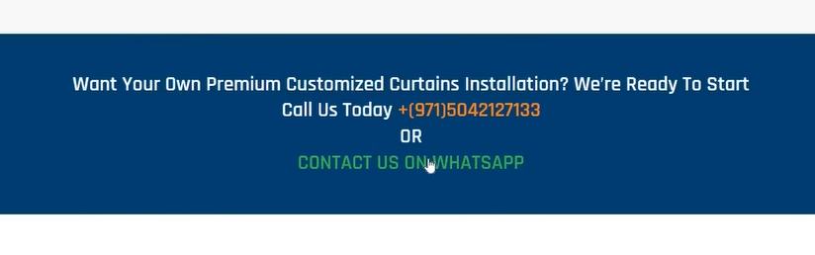

Now here is Contact US section

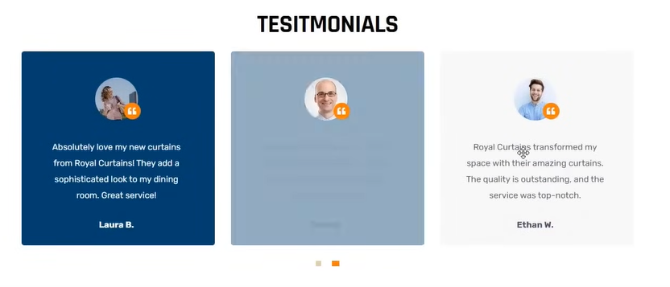

NOw we have testimonials

Testimonials are important for any tyoe of website

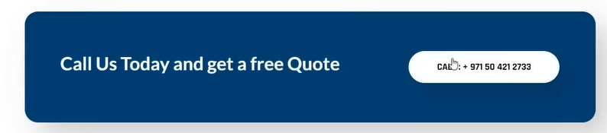

Now we have a contact bar as shown above

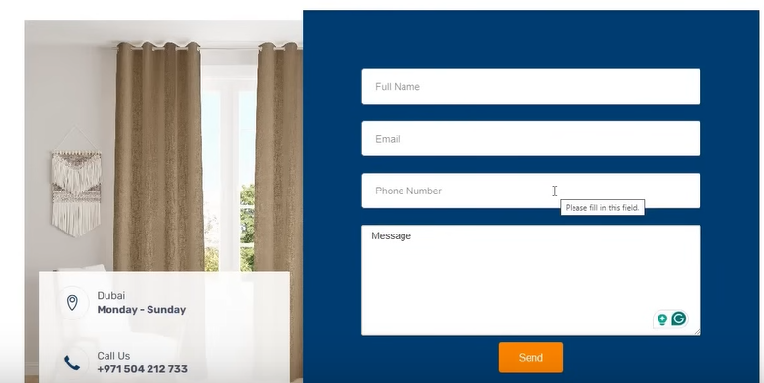

Now we have foprm as showna above

So its structure include is repeated call to action , simple clear headlines , short description , bullet description , more design less content

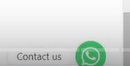

This floating icon is important

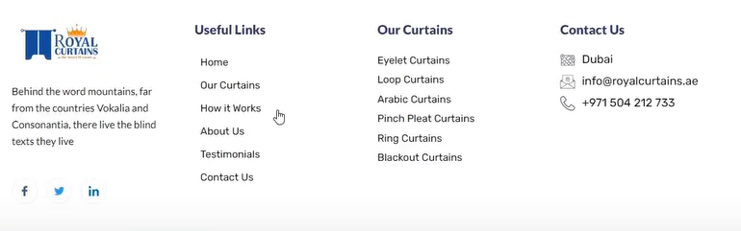

Now in footer an links are given such that they work the same way as we seein in menu

Here privacy policy link is not given but you have to put it there when you make alanding page yourself in future

Because google is very strict on this